**A One Stop Solution Focusing On Tourism**

## A PROJECT REPORT

***Submitted by,***

**Bhavana B A - 20211ISR0078**

**Disha R - 20211ISR0038**

**Monika P – 20211ISR0021**

### *Under the guidance of,*

**Dr. Alamelu Mangai Jothidurai**

**Associate Professor**

**GROUP NUMBER : ISR-G01**

***in partial fulfillment for the award of the degree of***

**BACHELOR OF TECHNOLOGY**

**IN**

INFORMATION SCIENCE ENGINEERING SPECIALIZATION TO ARTIFICIAL INTELLIGENCE AND ROBOTICS

**At**



**PRESIDENCY UNIVERSITY**

**BENGALURU**

**DECEMBER 2024**

**PRESIDENCY UNIVERSITY**

**SCHOOL OF COMPUTER SCIENCE ENGINEERING**

**CERTIFICATE**

This is to certify that the Project report **“A One Stop Solution Focusing On Tourism”** being submitted by “Bhavana B A, Disha R, Monika P” bearing roll number(s) “20211ISR0078, 20211ISR0038, 20211ISR0021” in partial fulfillment of the requirement for the award of the degree of Bachelor of Technology in Information Science Engineering Specialization to Artificial Intelligence and Robotics is a Bonafide work carried out under my supervision.

|  |  |
| --- | --- |
| **Dr. Akheela Khanum**  Program Project Reviewer  School of CSE&IS  Presidency University | **Dr. Zafar Ali Khan**  Professor & HoD  School of CSE&IS  Presidency University |

|  |  |  |
| --- | --- | --- |
| **Dr. L. SHAKKEERA**  Associate Dean  School of CSE  Presidency University | **Dr. MYDHILI NAIR**  Associate Dean  School of CSE  Presidency University | **Dr. SAMEERUDDIN KHAN**  Pro-Vc School of Engineering  Dean -School of CSE&IS  Presidency University |

**PRESIDENCY UNIVERSITY**

**SCHOOL OF COMPUTER SCIENCE ENGINEERING**

**DECLARATION**

We hereby declare that the work, which is being presented in the project report entitled **A One Stop Solution Focusing On Tourism** in partial fulfillment for the award of Degree of **Bachelor of Technology** in **Information Science Engineering Specialization to Artificial Intelligence and Robotics** , is a record of our own investigations carried under the guidance of  **Dr. Alamelu Mangai Jothidurai , Associate Professor,** **School of Computer Science Engineering & Information Science, Presidency University, Bengaluru.**

We have not submitted the matter presented in this report anywhere for the award of any other Degree.

|  |  |
| --- | --- |
|  | **Bhavana B A - 20211ISR0078**  **Disha R - 20211ISR0038**  **Monika P – 20211ISR0021**  **Signature(s) of the Students:** |

**ABSTRACT**

This project presents a tourist guide app designed to provide a comprehensive solution for travel needs, including car booking, hotel booking, and place recommendations tailored to user preferences. Many tourists find it challenging to locate all necessary services—such as booking and recommendations—within a single application, leading to significant inconvenience for the tourists all around.

Key Features

1.Car:

Users can search, compare, and book rental cars using filters for car type, price, and availability. The booking confirmation process is automated using UiPath.

2.Hotel:

A straightforward hotel search based on price and location. The booking form collects check-in/out and guest details, with an automated confirmation process.

3.Cab:

Integrating cab booking services to enhance transportation options.

4.User-Friendly:

The app features a clean design for easy navigation, an interactive map for exploring locations, and a chatbot for quick assistance.

**ACKNOWLEDGEMENT**

First of all, we indebted to the **GOD ALMIGHTY** for giving me an opportunity to excel in our efforts to complete this project on time.

We express our sincere thanks to our respected dean **Dr. Md. Sameeruddin Khan**, Pro-VC, School of Engineering and Dean, School of Computer Science Engineering & Information Science, Presidency University for getting us permission to undergo the project.

We express our heartfelt gratitude to our beloved Associate Deans **Dr. Shakkeera L and Dr. Mydhili Nair,** School of Computer Science Engineering & Information Science, Presidency University, and Dr. “Zafar Ali Khan”, Head of the Department, School of Computer Science Engineering & Information Science, Presidency University, for rendering timely help in completing this project successfully.

We are greatly indebted to our guide **Dr. Alamelu Mangai Jothidurai, Associate Professor** and Reviewer **Dr. Akheela Khanum**, School of Computer Science Engineering & Information Science, Presidency University for her inspirational guidance, and valuable suggestions and for providing us a chance to express our technical capabilities in every respect for the completion of the project work.

We would like to convey our gratitude and heartfelt thanks to the PIP2001 Capstone Project Coordinators **Dr. Sampath A K, Dr. Abdul Khadar A and Mr. Md Zia Ur Rahman,** department Project Coordinators “**Dr. Alamelu Mangai Jothidurai**” and Git hub coordinator **Mr. Muthuraj.**

We thank our family and friends for the strong support and inspiration they have provided us in bringing out this project.

**Bhavana B A**

**Disha R**

**Monika P**

**LIST OF TABLES**

|  |  |  |  |
| --- | --- | --- | --- |
| **Sl. No.** | **Table Name** | **Table Caption** | **Page No.** |
| 1 | Table 1.1 | System design and implementation blockdiagram | 12 |

2 Table 2.1 Time line for execution of project 13

3 Table 2.2 Gantt chart 13

**LIST OF FIGURES**

|  |  |  |  |
| --- | --- | --- | --- |
| **Sl. No.** | **Figure Name** | **Caption** | **Page No.** |
| 1  2  3 | Figure 1.1  Figure 1.2  Figure 1.3 | Screenshot  Screenshot  Screenshot | 19  19  19 |

**TABLE OF CONTENTS**

|  |  |  |
| --- | --- | --- |
| **CHAPTER NO.** | **TITLE** | **PAGE NO.** |
|  | **ABSTRACT ACKNOWLEDGMENT**  **LIST OF TABLES**  **LIST OF FIGURES** | **iv**  **v**  **vi**  **vii** |
| **1.** | **INTRODUCTION** | **1** |
| **2.** | **LITERATURE REVIEW** | **2** |
| **3.** | **RESEARCH GAPS OF EXISTING METHODS** | **4** |
| **4.** | **PROPOSED MOTHODOLOGY** | **7** |
| **5.** | **OBJECTIVES** | **11** |

**6. SYSTEM DESIGN & IMPLEMENTATION 12**

**7. TIMELINE FOR EXECUTION OF PROJECT 13**

**8. OUTCOMES 14**

**9. RESULTS AND DISCUSSIONS 15**

**10. CONCLUSION 16**

**11. REFERENCES 17**

**12. APPENDIX-A PSUEDOCODE 18**

**13. APPENDIX-B SCREENSHOTS 19**

**14. APPENDIX-C ENCLOSURES 20**

**CHAPTER-1**

**INTRODUCTION**

Introduction: A tourist guide app that offers car booking, hotel booking, and place recommendations, tailored to user needs.

Problem Statement: Many tourists struggle to find all services (booking, recommendations) in one app, leading to inconvenience.

1. Car Booking Users can search, compare, and book rental cars. Filters by car type, price, and availability. Automated booking confirmation with UI Path.

2. Hotel Booking Simple search for hotels by price and location. Booking form with check-in/out and guest details. Automated booking process for confirmations.

3. Place Recommendations Personalized suggestions based on user preferences Categories like restaurants, attractions, and shopping Nearby attractions using GPS.

4. User-Friendly Interface Clean design with easy navigation. Interactive map for exploring places and getting info.

**CHAPTER-2**

**LITERATURE SURVEY**

1.Luo, X., Li, H., & Zhang, Y. (2020).

Title: Integrating Tourism Services: A Framework for One-Stop Solutions

Summary: This paper proposes a framework for integrating multiple tourism services into a single platform. It emphasizes the importance of combining flight, hotel bookings, local tours, and customer support in one ecosystem. The study highlights the benefits of reduced transaction times, improved customer satisfaction, and increased economic efficiency for tourism operators. However, it also acknowledges challenges like scalability and data synchronization across service providers.

2.Wang, Y., Chung, N., & Buhalis, D. (2021).

Title: User Experience in Integrated Tourism Platforms: An Empirical Study

Summary: The paper focuses on how one-stop solutions enhance user experiences. Using an empirical study, it reveals that integrated platforms simplify travel decision-making, reduce cognitive load, and provide more personalized options based on user behavior. The authors find that seamless access to services via mobile apps and personalization algorithms are critical factors in user satisfaction.

3.Zheng, H., & Wang, Q. (2019).

Title: AI and Machine Learning in Personalized Travel Services Summary:

Summary: This research delves into the role of artificial intelligence in personalizing one-stop tourism platforms. It shows how machine learning algorithms analyze large datasets of user preferences and behaviors to offer tailored recommendations for travel itineraries, accommodations, and activities. The study suggests that AI not only enhances customer engagement but also increases retention rates.

4.Mariani, M., & Baggio, R. (2020).

Title: Smart Destinations and One-Stop Tourism Solutions: Challenges and Opportunities

Summary:

This paper examines the rise of smart tourism destinations and their role in promoting one-stop solutions. It discusses how smart technologies, like IoT (Internet of Things) and real-time data, contribute to creating an integrated tourism experience. The authors emphasize the importance of collaboration among tourism stakeholders and the need for robust technical infrastructure to support real-time updates and services.

5.Zhang, J., & Huang, W. (2022).

Title: Blockchain and the Future of Integrated Tourism Platforms

Summary: The study explores how blockchain technology could revolutionize one-stop tourism solutions. It discusses the role of smart contracts in securing transactions and ensuring trust between travelers and service providers. The research also addresses the potential for decentralized tourism ecosystems, where peer-to-peer services could replace traditional platforms. The authors argue that blockchain enhances transparency, especially in booking and payment processes.

6.Aguilar, G., Chen, T., & Kim, J. (2021).

Title: Mobile Technologies and One-Stop Solutions in Tourism: A Comprehensive Review

Summary:

This paper reviews the role of mobile technologies in providing integrated tourism solutions. It highlights how mobile apps serve as gateways to access booking services, local guides, real-time transportation, and even augmented reality tours. The authors argue that the rise of mobile-first platforms has made travel planning and real-time navigation more convenient for users globally.

7.Li, X., & Pearce, P. (2020).

Title: Cultural Experiences in One-Stop Tourism Platforms

Summary: This research focuses on how one-stop tourism platforms integrate cultural experiences into their offerings. It finds that many travelers seek out unique, localized activities, which can now be easily booked through integrated platforms. The paper highlights the role of partnerships with local businesses to create authentic experiences and improve cultural sustainability through digital exposure.

8.Alizadeh, S., & Isa, M. (2021).

Title: Sustainability in Integrated Tourism Solutions: A Focus on Eco-Friendly Tourism

Summary:

This paper addresses the growing trend of sustainable tourism within one-stop solutions. It examines how platforms are beginning to incorporate environmentally friendly options, such as eco-lodges, carbon-neutral transportation, and sustainable activities, into their offerings. The authors argue that this not only appeals to eco- conscious travelers but also promotes long-term sustainability in the tourism sector.

9.Buhalis, D., & Sinarta, Y. (2019).

Title: Real-Time Data and Personalized Travel Experiences: A Shift in One-Stop Solutions

Summary:

The paper discusses the use of real-time data analytics to offer dynamic travel experiences. The authors explore how one-stop platforms use real-time data to update users on flight changes, local weather, event cancellations, and even personalized recommendations based on their current location. They argue that real-time responsiveness significantly enhances user experience and allows travelers to adapt their plans quickly.

**CHAPTER-3**

**RESEARCH GAPS OF EXISTING METHODS**

Despite the advancements in travel automation and related technologies, several research gaps exist in the current landscape. These include:

1. Limited Integration Across Platforms

Existing solutions often focus on specific aspects of travel, such as flights or accommodations, without offering a comprehensive, unified platform.

There is a lack of seamless integration that combines food delivery, accommodations, transportation, and local activities into a single app.

2. Real-Time Personalization

While many platforms provide recommendations based on user preferences, they often lack real-time adjustments. For example, a traveler’s itinerary or preferences might change mid-trip, but the system doesn’t dynamically adapt.

3. Data Reliability and Scraping Challenges

Web scraping for aggregating data from multiple sources can face challenges such as inconsistent formats, blocked access, or outdated information.

There’s limited research on how to maintain data integrity while scaling scraping operations for diverse platforms.

4. Insufficient AI Utilization

Many current systems use basic algorithms for recommendations but lack advanced AI-driven personalization that can consider complex factors like travel mood, cultural preferences, or sustainability goals.

5. Lack of Focus on Sustainability

Few travel automation apps prioritize eco-friendly options, such as sustainable accommodations or carbon-neutral transport.

There is limited integration of green tourism recommendations in mainstream platforms.

6. Customer Support Limitations

Existing chatbots often provide scripted responses, struggling to address nuanced or complex queries.

There’s a gap in using conversational AI to offer more intuitive, human-like customer interactions.

7. Regional and Cultural Limitations

Many travel apps are region-specific or cater predominantly to global metropolitan areas, leaving gaps in coverage for less popular or rural destinations.

Language barriers and localization are still major hurdles.

8. Privacy and Security Concerns

While automation streamlines processes, data privacy and security measures often lag behind, especially in handling sensitive payment or personal information.

Existing Methods

1. Travel Aggregators

Platforms like Expedia, Booking.com, and Kayak aggregate travel options such as flights, hotels, and rental cars.

Limitation: These focus on specific categories and lack integration with other travel needs like food or local activities.

2. Recommendation Engines

Apps like TripAdvisor or Google Travel use algorithms to recommend destinations and services based on user reviews, ratings, and preferences.

Limitation: They often rely on user-generated content, which can be biased or inconsistent, and do not always provide real-time updates.

3. Food Delivery and Restaurant Aggregators

Platforms like Swiggy, Zomato, and Uber Eats specialize in local food delivery and dining options.

Limitation: These operate independently of travel apps, requiring users to switch between multiple platforms during a trip.

4. Standalone Chatbots

Chatbots like those used by airlines or hotels provide customer support for specific queries (e.g., booking changes or cancellations).

Limitation: They lack cross-platform functionality and can’t address queries spanning multiple services or platforms.

5. Manual Web Scraping

Some systems use basic web scraping tools to gather data for price comparison or reviews.

Limitation: Manual scraping is labor-intensive, prone to errors, and may violate platform policies.

6. Itinerary Builders

Tools like TripIt and Sygic Travel help users organize their itineraries based on bookings and personal inputs.

Limitation: These tools do not actively fetch or recommend options from external platforms.

7. Specialized Platforms for Sustainable Travel

Apps like Ecotourism.org or Responsible Travel focus on green tourism options.

Limitation: These cater to niche audiences and lack integration with mainstream travel services.

8. RPA in Automation

Robotic Process Automation tools like UiPath are used in business applications, including limited use cases in travel for tasks like invoice processing or basic data aggregation.

Limitation: The full potential of RPA for end-to-end travel planning and real-time updates has not been extensively explored.

**CHAPTER-4**

**PROPOSED MOTHODOLOGY**

UiPath Studio Implementation

We have successfully implemented data scraping across various websites, including hotel booking, online food ordering, and cab booking platforms. This method enables users to access a range of services through a single interface, allowing for easy comparisons and informed choices without switching between applications.

Design Phase Workflow Design

Using UiPath Studio to create flowcharts or sequence diagrams that outline the automation process.

UI/UX Design

Design user interfaces for forms and dashboards as part of the automation.

Technology Stack Selection UiPath Tools:

Utilize UiPath Studio for development, Orchestrator for deployment, and UiPath Assistant for user interactions.

Integration

Identify other applications (e.g., databases, APIs) that will interact with UiPath workflows.

Data Layer

The data layer manages all user-related information, including bookings, transactions, reviews, and analytics. It also handles caching, indexing, and database management.

Key Databases:

1.Relational Databases (RDBMS): MySQL or PostgreSQL for structured data like user information and booking records.

2.NoSQL Databases: MongoDB or Cassandra for unstructured data such as reviews and recommendations.

3.In-memory Databases: Redis or Memcached for caching frequently accessed data.

4.Data Warehousing: Amazon Redshift, Google BigQuery, or Snowflake for large- scale data analytics.

5.Search Indexing: Elasticsearch for fast search queries, especially for Tourism Challenges Addressed by UiPath Automation

1.Repetitive Tasks:

Activities like booking confirmations, payment processing, and customer follow-ups are time-consuming and prone to human error.

2.Fragmented Systems:

Tourism companies often work with multiple platforms (travel agency portals, hotel booking systems, and transportation networks), leading to inefficiencies in integration and data sharing.

3.High Customer Expectations:

Travelers demand seamless, personalized, and instant responses to queries and services, creating pressure on service providers.

4.Cost Pressures:

Manual processes increase labor costs and limit scalability during peak seasons.

5.Data Overload:

Managing customer preferences, feedback, and booking historiesbecomes overwhelming without automation.

UiPath’s automation capabilities provide a unified solution to these challenges, enabling the tourism industry to deliver better results with fewer resources.

Applications of UiPath Automation in Tourism

1.Booking and Reservation Management

Managing bookings across multiple platforms is complex and error-prone when done manually.

Automation Workflow:

Extract customer details from emails, chatbots, or forms.

Automatically book flights, hotels, or transportation services based on preferences.

Confirm availability and send real-time booking confirmations to customers. Outcome: Reduced manual intervention and improved accuracy in bookings.

Personalized Itinerary Creation

2.Creating tailored itineraries based on customer interests is a vital aspect of modern tourism.

Automation Workflow:

UiPath robots extract customer preferences (e.g., preferred destinations, budget, travel dates).

Data is consolidated from travel websites, local guides, and reviews.

An automated itinerary is generated and shared with the customer via email or mobile apps.

Outcome: Faster delivery of personalized travel plans with minimal human

effort.

3.Streamlined Customer Service

Customer queries, complaints, and real-time assistance are crucial for maintaining satisfaction.

Automation Workflow:

Use UiPath chatbots to handle routine inquiries such as refund policies, itinerary changes, and status updates.

Automate complaint ticketing and escalate unresolved issues to human agents. Provide 24/7 customer support with real-time updates.

Outcome: Improved customer satisfaction with faster query resolution and consistent service quality.

4.Marketing and Campaign Management

Promoting travel packages and engaging customers effectively are essential for revenue growth.

Automation Workflow:

Automate email campaigns, tailoring offers to specific customer segments. Extract insights from customer feedback and booking trends using analytics tools.

Schedule and manage social media campaigns.

Outcome: Enhanced marketing efficiency with targeted promotions that drive higher conversions.

5.Backend Operations

Manual backend tasks, such as invoice generation, payment processing, and compliance checks, can be cumbersome and slow.

Automation Workflow:

Automatically generate invoices and reconcile payments with booking data.

Manage supplier contracts and regulatory compliance through document automation.

Input and validate data in legacy systems without human intervention.

Outcome: Streamlined back-office operations, reducing processing time and error rates.

Key Benefits of UiPath Automation in Tourism

1.Cost Savings

Reduction in labor costs by automating repetitive tasks. Improved resource allocation during off-peak and peak seasons.

2.Operational Efficiency

Automation ensures faster task completion with minimal errors.

End-to-end process automation enables seamless integration across platforms.

3.Enhanced Customer Experience

Personalized itineraries and instant services create higher satisfaction. Automated responses ensure 24/7 availability for customer support.

4.Scalability

UiPath robots can handle increased workloads during peak tourist seasons. Automation supports rapid adaptation to changing customer demands and trends.

5.Data-Driven Decision-Making

Reliable data extraction and processing provide actionable insights.

Automated analytics tools identify trends to inform marketing and service strategies.

Case Study: Transforming a Travel Agency with UiPath Automation

Background: A mid-sized travel agency faced challenges in managing customer bookings and delivering personalized itineraries. Manual processes resulted in delayed responses, errors in bookings, and reduced customer satisfaction.

Solution:

UiPath robots were deployed to automate booking confirmations, itinerary generation, and customer service.

Chatbots integrated with UiPath handled 80% of customer queries.

Backend operations, including invoice generation and compliance reporting, were fully automated.

Results:

Booking processing time reduced by 70%. Customer satisfaction scores increased by 30%.

Operational costs decreased by 40%, allowing the agency to reallocate resources to strategic growth initiatives.

Implementation Steps for UiPath in Tourism

1.Identify Automation Opportunities

Map out repetitive and time-consuming tasks within the organization.

2.Develop a Roadmap

Start with high-impact processes such as bookings and customer service. Scale to include backend operations and marketing.

3.Integrate UiPath with Existing Systems

Ensure compatibility with CRM, ERP, and booking platforms.

4.Train Staff

Equip employees with skills to work alongside UiPath robots effectively.

5.Monitor and Optimize

Regularly review automation workflows to ensure continuous improvement.

**CHAPTER-5**

**OBJECTIVES**

**1**.**Simplified Hotel Booking**: Users will have the ability to book accommodations effortlessly through an intuitive interface that aggregates options from multiple platforms. This feature will allow travelers to compare prices, read reviews, and select hotels that best fit their needs, all in one place.

**2.Online Food Ordering:** To cater to the diverse culinary preferences of travelers, the app will include a convenient online food ordering system. Users can browse local restaurants, explore menus, and place orders for delivery or pickup, ensuring they can enjoy local cuisine with ease.

**3.Cab Booking Services:** Recognizing the importance of reliable transportation while traveling, the app will offer cab booking services. Users can book rides quickly and securely, ensuring they can navigate their destinations without hassle.

**4.Chatbot Feature:** To provide real-time assistance, the app will incorporate a chatbot that tourists can interact with to ask questions and receive immediate responses. This feature aims to enhance the user experience by offering support for common inquiries, such as local attractions, transportation options, and dining recommendations.

**5.Multilingual Support:** To ensure inclusivity, the app will support two languages: English and Hindi. This feature will help cater to a broader audience, making the app accessible to both international tourists and local travelers. By integrating these functionalities, the app aims to be an all-in-one solution for travelers, simplifying their journey and enhancing their overall experience.

**CHAPTER-6**

**SYSTEM DESIGN & IMPLEMENTATION**

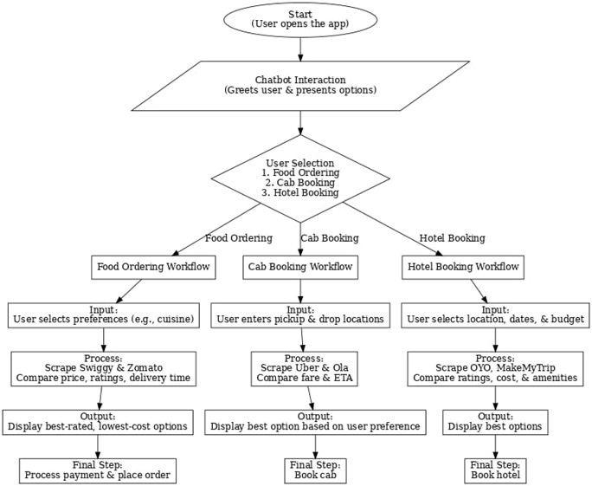

Table 1.1

**CHAPTER-7**

**TIMELINE FOR EXECUTION OF PROJECT**

**(GANTT CHART)**

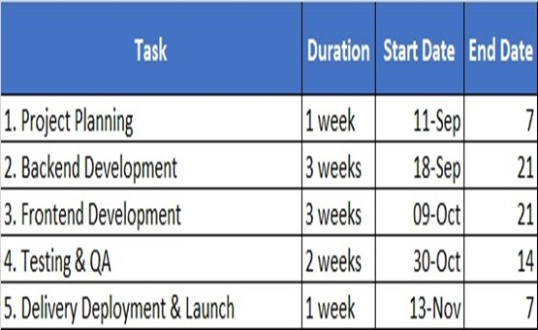

Table 2.1

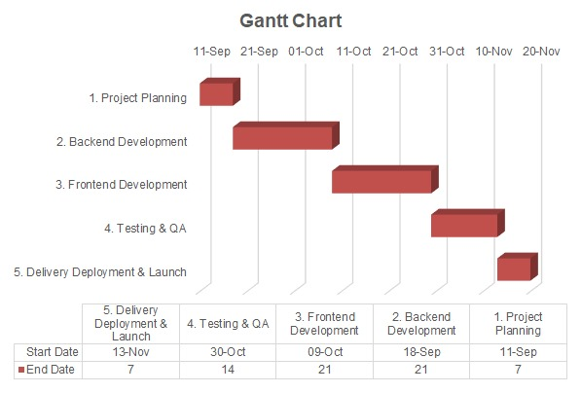

Table 2.2

**CHAPTER-8**

**OUTCOMES**

**Technological Outcomes**

Demonstration of UiPath's Capabilities

The app showcases the potential of UiPath for automating complex, multi-step workflows in real-world applications.

Demonstrates how web scraping, data integration, and chatbot functionalities can be seamlessly combined to create user-centric solutions.

Scalable and Customizable Workflow

The app’s modular design allows for easy scaling to include additional platforms or services.

Customization options can cater to specific user demographics, destinations, or travel trends.

AI-Driven Enhancements

Integration of machine learning models for advanced recommendation systems could further refine the app’s effectiveness.

The chatbot’s AI-based functionality enhances user interaction and support, making the system more dynamic and responsive.

**Societal Outcomes**

Promotion of Budget-Friendly Travel

By identifying affordable options, the app supports budget-conscious travellers and promotes equitable access to travel opportunities.

Encouragement of Sustainable Choices

Incorporating eco-friendly recommendations (e.g., sustainable accommodations or local dining options) can contribute to responsible tourism practices.

Support for Local Economies

The app can promote smaller, lesser-known businesses that offer competitive prices and good ratings, boosting local economies.

Increased Travel Accessibility

Streamlined automation and a user-friendly interface make the app accessible to a broader audience, including those who may find manual travel planning daunting.

**CHAPTER-9**

**RESULTS AND DISCUSSIONS**

The comprehensive travel automation app achieves its primary objective of streamlining the travel planning and booking process through advanced automation powered by UiPath. Key results include:

1. Enhanced User Experience:

Simplifies the search for affordable and high-quality options for food, hotels, and rooms by aggregating data from multiple platforms.

Provides real-time, data-driven recommendations based on price, ratings, and reviews.

1. Time and Cost Efficiency:

Automation eliminates the need for manual comparisons, significantly reducing the time spent on planning.

Helps users save money by identifying the best deals across various platforms.

1. Improved Customer Support:

A built-in chatbot ensures 24/7 assistance, resolving queries and improving user satisfaction.

1. Business Growth for Stakeholders:

Partner platforms like Swiggy, Zomato, and hotel booking sites gain increased visibility and traffic.

Enhanced revenue streams through a seamless and efficient booking process.

1. Technological Innovation:

Demonstrates UiPath’s capability in handling end-to-end workflows, including web scraping, integration, and AI-based chatbots.

Provides a scalable and adaptable framework for future expansions.

1. Societal Impact:

Promotes budget-friendly travel, supporting equitable access to travel opportunities.

Encourages sustainable practices and boosts local economies by highlighting smaller businesses and eco-friendly options.

**CHAPTER-10**

**CONCLUSION**

The development of this one-stop tourism solution addresses the increasing demand for seamless, personalized, and efficient travel experiences. By integrating services such as flight and accommodation bookings, local experiences, dining reservations, and real- time assistance into a single platform, travelers can effortlessly manage every aspect of their journey.

The solution employs advanced technologies like AI, mobile-first design, and cloud architecture to offer personalized recommendations and enhance user experiences while maintaining scalability. Moreover, the focus on sustainability and ethical tourism aligns with the modern traveler's desire for responsible and eco-friendly options.

It aims to revolutionize the travel experience by providing a seamless, integrated platform for tourists, making travel planning simpler and more enjoyable. By combining a robust digital platform with local partnerships and personalized services, this project has the potential to attract a large audience, generate revenue through various channels, and contribute to the growth of the tourism industry.

**REFERENCES**

1.S. Becken, "Sustainable Tourism: An Overview," Tourism Management, vol. 58,

pp. 1-12, 2017.

2.D. Buhalis, eTourism: Information Technology for Strategic Tourism Management, Pearson Education, 2003.

3.D. Buhalis and R. Law, "Progress in Information Technology and Tourism Management: 20 Years on and 10 Years After the Internet," Tourism Management, vol. 29, no. 4, pp. 609-623, 2008.

4.M. A. González et al., "Sustainable Tourism and Its Impact on the Local Economy," Journal of Tourism Research, vol. 22, no. 2, pp. 95-108, 2019.

5.C. H. C. Hsu and S. Huang, "Integrating Travel Services and Experience: A New Business Model," Journal of Travel Research, vol. 55, no. 3, pp. 365-378, 2016.

6.T. Huang et al., "The Impact of Augmented Reality on Tourist Experiences,"

Tourism Management, vol. 85, 2021, Art. no. 104274.

7.R. J. Kwortnik and G. M. Thompson, "Unifying Service Marketing and Operations with Service Experience Management," Journal of Service Research, vol. 11, no. 4, pp. 389-406, 2009.

8.X. Li et al., "Personalization in Tourism: A Study of User Preferences," Journal of Travel & Tourism Marketing, vol. 35, no. 4, pp. 421-435, 2018.

9.S. B. Mackenzie et al., "Artificial Intelligence in the Tourism Industry: The Future of Travel," International Journal of Hospitality Management, vol. 88, 2020, Art. no. 102463.

10.World Tourism Organization, "Global Report on the Trends in Tourism," UNWTO, 2021.

**APPENDIX-A**

**PSUEDOCODE**

Message Box:

Display the message: "Welcome! What would you like to prefer?"

Display the options: "1. Booking hotels/room 2.food"

Input Dialog:

Prompt the user to enter their choice.

Store the user's input in the variable choice.

If-Else Condition:

If choice is equal to "1":

Open Browser:

Navigate to the MakeMyTrip website.

Else if choice is equal to "2":

Open Browser:

Navigate to the Swiggy website.

Else:

Message Box:

Display an error message indicating an invalid choice.

**APPENDIX-B**

**SCREENSHOTS**

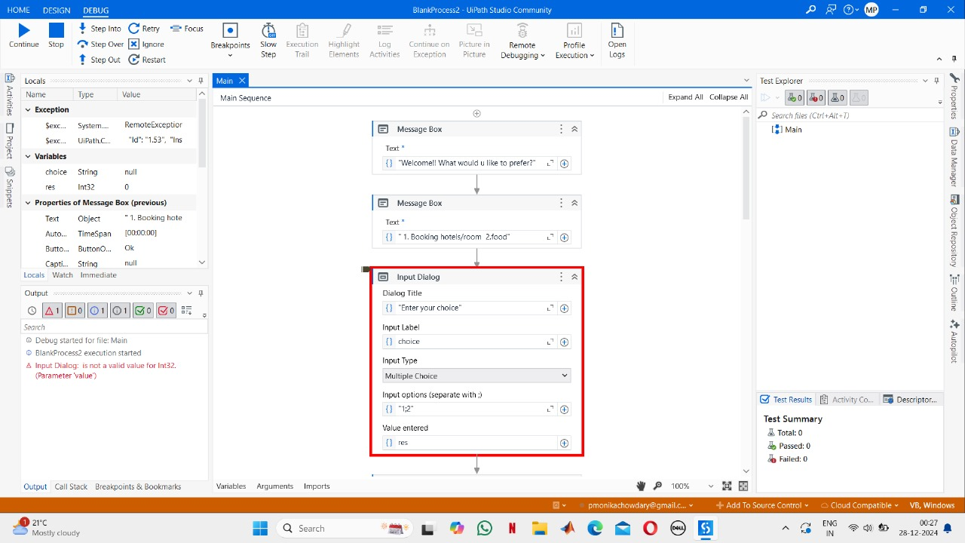

Fig 1.1

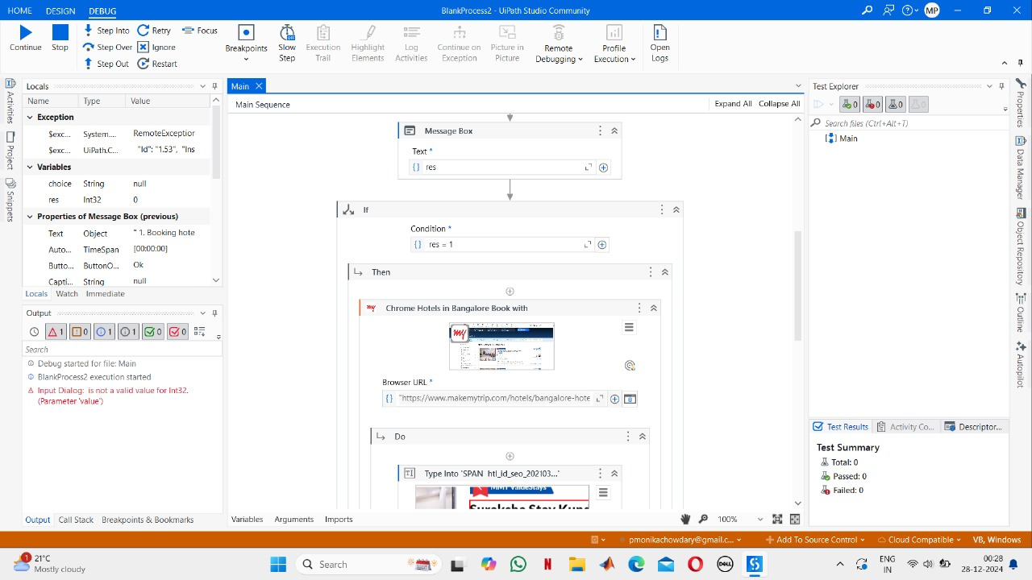

Fig 1.2

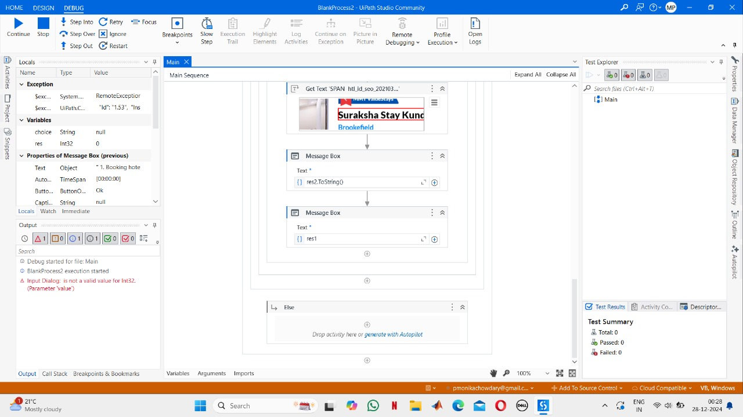

Fig 1.3

**APPENDIX-C**

**ENCLOSURES**

**1. Journal publication/Conference Paper Presented Certificates of all students.**

**2. Include certificate(s) of any Achievement/Award won in any project-related event.**

**3. Similarity Index / Plagiarism Check report clearly showing the Percentage (%). No need for a page-wise explanation.**

**4.** **Details of mapping the project with the Sustainable Development Goals (SDGs).**